D803 Natural Language Processing
Robert Kuprenas
Student ID: 012611549
Part 2
____________________________________________________________________________________
A. GitLab Repository Branch History Screenshot
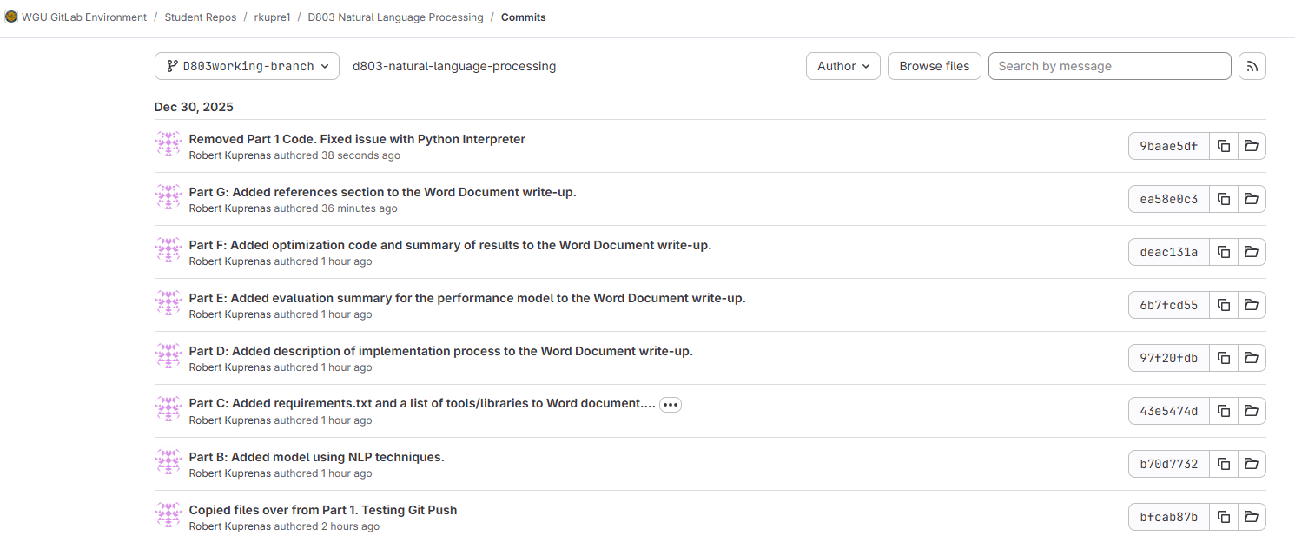
____________________________________________________________________________________
B. Design a working model in Gitlab using NLP techniques.
A supervised natural language processing model was designed to perform sentiment classification on Amazon product reviews. The cleaned review text was transformed into numerical features using Term Frequency–Inverse Document Frequency (TF-IDF) vectorization, which captures the relative importance of words across documents. A logistic regression classifier was selected as a baseline model due to its effectiveness and interpretability for text classification tasks. The model was trained using a stratified train-test split to ensure balanced sentiment representation and implemented in Python within a GitLab project repository.

____________________________________________________________________________________
C. Prepare a write-up describing the libraries and tools necessary for implementing the design.
This NLP system was implemented in Python using a standard machine learning workflow for text classification. Development and experimentation were performed in PyCharm and a Jupyter notebook. GitLab was used for version control to support reproducibility.
Core data preparation and modeling relied on widely used Python libraries. pandas was used to load and manipulate the CSV dataset, while NumPy supported basic array operations when needed. The model was built with scikit-learn, using TF-IDF vectorization to convert cleaned review text into numeric features and a logistic regression supervised classifier to predict sentiment labels. For evaluation, scikit-learn’s metrics utilities were used to generate accuracy, precision, recall, F1-score, and a confusion matrix, while Matplotlib was used to visualize the confusion matrix for clearer interpretation of results.
Tools
- PyCharm: IDE for project organization, debugging, and Git integration
- Jupyter Notebook: step-by-step experimentation and documentation
- GitLab: version control and submission repository
- Python: dependency management and reproducibility
Libraries
- pandas: read/clean CSV data
- NumPy: supporting numeric operations
- scikit-learn: TF-IDF, train/test split, model training, metrics, confusion matrix
- Matplotlib: plots (confusion matrix visualization)

____________________________________________________________________________________
D. Describe the implementation process of the NLP system, using parts B and C.
The implementation of the NLP system followed a structured supervised learning workflow for sentiment classification. After completing data cleaning and normalization in Part 1, the cleaned review text was loaded from a CSV file stored within the GitLab repository using relative file paths to ensure portability across environments. The dataset was then divided into training and testing subsets using a stratified split to preserve class distribution and reduce evaluation bias. This approach supports more reliable performance assessment by ensuring that both sentiment classes are represented proportionally during training and evaluation (Lin et al., 2023).
Next, the textual data was transformed into numerical features using Term Frequency–Inverse Document Frequency (TF-IDF) vectorization. TF-IDF was selected because it captures both term frequency within individual documents and the relative importance of terms across the entire text, making it well suited for sentiment analysis tasks involving short to medium-length text such as product reviews (Lin et al., 2023). The vectorized features were passed into a logistic regression classifier implemented using the scikit-learn library. Logistic regression provides an efficient and interpretable baseline model for text classification, particularly when paired with high-dimensional sparse feature representations produced by TF-IDF.
The model training and evaluation process was implemented using a reproducible pipeline architecture, allowing preprocessing and classification steps to be executed consistently across datasets. Predictions generated from the trained model were evaluated on the held-out test set using standard classification metrics, including accuracy, precision, recall, F1-score, and a confusion matrix. These metrics collectively provide insight into both overall model performance and class-specific prediction behavior, supporting informed decisions for future optimization and refinement (Rainio et al., 2024).

____________________________________________________________________________________
E. Provide an evaluation summary for the performance of the model (e.g., accuracy, precision, recall, F1-score, and confusion matrix).
The model was very accurate at predicting negative reviews when the reviews were actually negative. It was not as accurate at predicting positive reviews, labeling around a third of them negative, even when they were supposed to be positive. Likely causes for this include reviews stating small negative things about a product, while still giving an overall positive review. The predictive model had trouble differentiating between actual negative reviews, and positive reviews that included some negative tokens.
Overall model performance achieved an accuracy of 0.82, indicating that the classifier correctly predicted sentiment for most reviews in the test dataset. However, accuracy alone does not fully reflect class-specific performance. For negative reviews, the model demonstrated strong performance with a precision of 0.78 and a recall of 0.93, showing that most actual negative reviews were correctly identified. In contrast, positive reviews achieved a higher precision of 0.89 but a lower recall of 0.70, indicating that while predicted positive labels were usually correct, a substantial number of positive reviews were misclassified as negative. This imbalance is reflected in the F1-scores, with negative reviews achieving a higher F1-score (0.85) than positive reviews (0.78) (Rainio et al., 2024; Sokolova & Lapalme, 2022).
The confusion matrix further clarifies this classification behavior by revealing a greater number of false negatives for the positive class. Specifically, 28 positive reviews were incorrectly labeled as negative, compared to only 8 negative reviews mislabeled as positive. This suggests that the model is more conservative in assigning positive sentiment and may place greater weight on negative tokens during prediction. These results highlight areas where model refinements, such as feature adjustments or hyperparameter tuning, may improve balanced performance across sentiment classes.

____________________________________________________________________________________
F. Provide a detailed summary on the optimization of the NLP model (e.g., tune hyperparameters, adjust the architecture, try different algorithms, or use additional techniques like data preparation to improve performance).
To improve balanced classification performance, several optimization techniques were applied to the baseline NLP model. A grid search with cross-validation was used to tune key hyperparameters, including the regularization strength of the logistic regression classifier, the use of class weighting, and the n-gram range of the TF-IDF vectorizer. Class weighting was introduced to address the imbalance observed in recall between sentiment classes during the initial evaluation, while expanding the n-gram range allowed the model to better capture contextual word patterns such as short phrases that contribute to sentiment meaning (Henning et al., 2023). These adjustments were evaluated using macro-averaged F1-score to ensure that performance improvements were distributed more evenly across both sentiment classes rather than favoring a single class.
The optimized model selected a lower regularization parameter (C = 0.1), enabled balanced class weights, and incorporated both unigrams and bigrams in the TF-IDF representation. Compared to the baseline model, these changes resulted in more balanced precision and recall values between negative and positive reviews. In particular, recall for the positive class increased from 0.70 to 0.78, while recall for the negative class remained strong, indicating improved sensitivity to positive sentiment without sacrificing negative sentiment detection. Although overall accuracy remained similar, the optimized model demonstrated improved class-level consistency, as reflected in the macro-averaged F1-score and a more evenly distributed confusion matrix (Lin et al., 2023).
These results highlight the importance of targeted hyperparameter tuning and feature representation adjustments in NLP systems. Rather than focusing solely on maximizing accuracy, the optimization process emphasized balanced performance across classes, which is especially important in sentiment analysis tasks where mixed or nuanced language is common. The refined model provides a stronger foundation for real-world deployment and demonstrates best practices for iterative NLP system improvement through controlled experimentation and metric-driven evaluation (Rainio et al., 2024).

____________________________________________________________________________________
G. Acknowledge sources, using APA-formatted in-text citations and references, for content that is quoted, paraphrased, or summarized.
Sources:
Henning, S., Stiefelhagen, R., & others. (2023). A survey of methods for addressing class imbalance in deep-learning based natural language processing. Proceedings of the 17th Conference of the European Chapter of the Association for Computational Linguistics (EACL 2023). Association for Computational Linguistics.
https://aclanthology.org/2023.eacl-main.38/
Lin, Y.-C., Chen, S.-A., Liu, J.-J., & Lin, C.-J. (2023). Linear classifier: An often-forgotten baseline for text classification. Proceedings of the 61st Annual Meeting of the Association for Computational Linguistics (ACL 2023). Association for Computational Linguistics. https://aclanthology.org/2023.acl-short.160/
Rainio, O., Teuho, J., & Klén, R. (2024). Evaluation metrics and statistical tests for machine learning. Scientific Reports, 14, Article 6086. https://doi.org/10.1038/s41598-024-56706-x
Sokolova, M., & Lapalme, G. (2022). A systematic analysis of performance measures for classification tasks. Information Processing & Management, 59(2), 102802.
https://doi.org/10.1016/j.ipm.2021.102802

